Introduction:

1.1 Overview

Fashion Haven is private limited company also registered under GST in Tamil Nadu. Fashion Haven is a retailer of various lifestyle products in wholesale and retail, it has a wide range of customers (B2B B2C) all over the state and it procures from various suppliers in the state. It operates at a Gross Profit margin of 50%.

1.2 Purpose

Fashion Haven, an online retail store, leverages Zoho Books to manage their inventory and track sales. They can generate invoices and manage customer payments seamlessly. Zoho Books also enables them to reconcile bank transactions and generate financial reports, helping them make informed decisions about their business..

2. Problem Definition & Design Thinking

A) Empathy Map

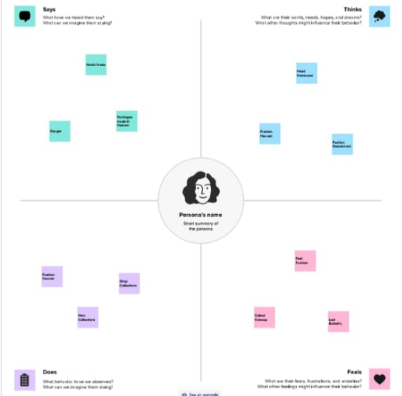

B) Ideation & Brainstorming Map

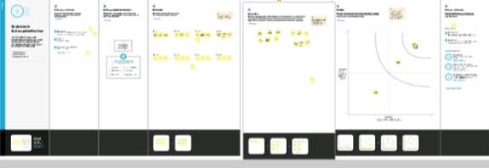

3 Result

A) Profit & Loss A/c

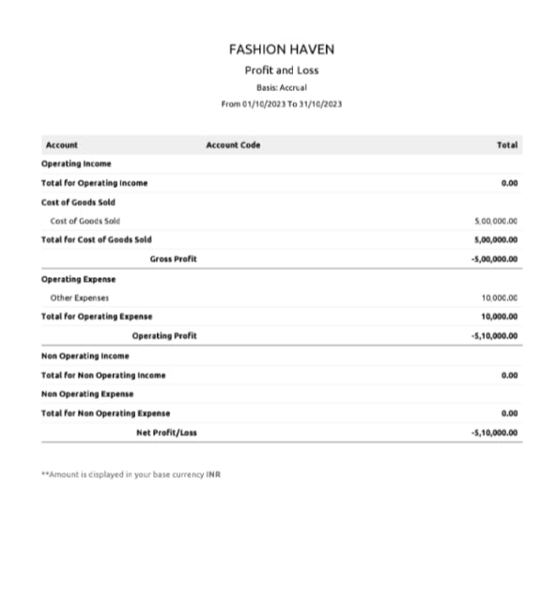

B) Balance Sheet

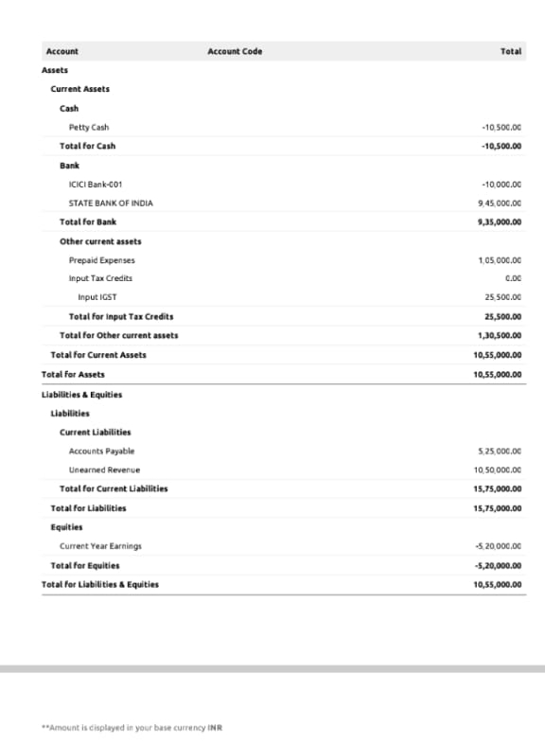

4) Advantages & Disadvantages

ADVANTAGES

1) Invoicing and Billing

2) Expense tracking

3) Minimize Data Lost

4) Report Generation

5) Inventory Management

DISADVANTAGES

1) Difficult to Modify Invoice

2) Maximum of 10 Users

3) Time Tracking must be tied to Project

4) Limited Bank Syncing

5) Difficult to Modify Bills

APPLICATION

The Zoho books are applied in our business to record the sales and purchase to generate invoice and bill and manages the customer payment and vendor payment. It also maintain the expense and other transaction related to the business. And we can also maintain the cash book and bank account in this cloud based accounting software. It also gives all the financial report about the profit & loss A/C, Balance Sheet, GST Report Account Receivable AR Aging Details, Account Payable AR Aging Details and etc . This all the details can help to make decision making for future business Purposes.

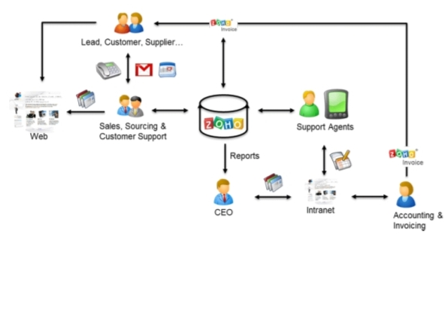

6) CONCLUSION

The zoho books are usefull to maintain , record, Summarize and analysis accounting entries made in this cloud based software.We need any manual records to maintain the accounts. That the transacation are recorded while the entering in this software. Then we can add the journal and then we can get the profit and loss A/C, Balance Sheet, GST Report and etc. We don’t need one software to enter bill and another software to maintain accounts . We can prepare the bill and maintain accounts in one software.

7) FUTURE SCOPE

1) If best software to maintain accounts and billing, so we need not tally.

2) This will be used by most company to maintain accounts in their company.

3) There is need not any accountant to record the transaction.

4) Reduced the time to maintain accounts.